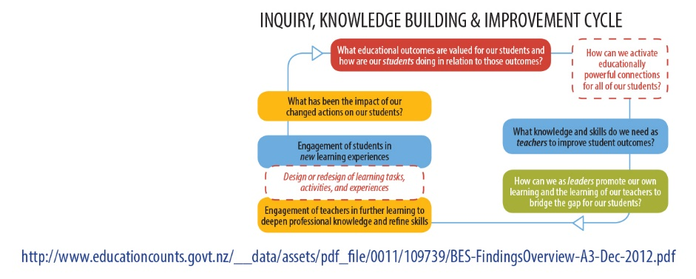
HOW DOES YOUR SCHOOL’S PICTURE COMPARE TO THE NATIONAL PICTURE?
 | NATIONAL PICTURE | SCHOOL PICTURE
What big picture trends and patterns are apparent in the data (strengths/areas for development)?
Did you find any surprises in the data? What were they?
How does this data meet your expectations for learning?
Are all groups of students making suitable progress i.e, a year’s progress in a year?
Which groups /year level /cohorts of students appear to be achieving below the National Standards?
What gaps in achievement exist between any groups of students, especially for your priority groups of students?
What does this data tell you about the priorities for students at key transition points e.g. Year 1, 3, 7?
PRIORITY STUDENTS
The purpose of this section is to inquire into school data to reflect on the strengths and needs of your own groups of students and the actions taken to address these needs.
SCHOOL PROGRESS AND ACHIEVEMENT PICTURE
How many students at each year level in your school are not yet achieving at the NZC National Standards?
Is this a pattern of achievement that has existed over the past few years?
From the data, what are the identified learning needs of your priority students?
Which areas (reading, writing and maths) does your data show require further attention?
What classroom strategies have you tried to raise the achievement levels of these students?
What has worked?
What needs to be maintained?
What hasn’t worked as well as you thought it would?
What needs to be stopped?
What programme(s), e.g. Reading Recovery, do you currently have in place to raise the achievement levels of these students?
Are these having an accelerative effect? If not, what will you stop or do differently?
To what extent does the data highlight any professional learning needs for individual teachers?

